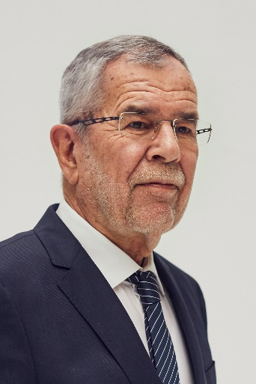
Statement from the President of the Federal Republic of Austria, Alexander Van der Bellen,
on the occasion of the European Day of Languages,
26th September 2019

Openness, tolerance and rejection of hate at all levels of society are key indicators of a strong, value-conscious and successful Europe.
At the initiative of the Council of Europe, the European Day of Languages (EDL) has been celebrated every year, on 26 September since 2001 – a call to encourage all European citizens to learn languages and to recognise and appreciate Europe's cultural diversity.
This special day represents an occasion to celebrate the many languages spoken within our countries and across our communities, and to demonstrate that all voices in Europe are treated with equal respect. These are the values of the Council of Europe, the continent’s oldest intergovernmental organisation which this year celebrates its 70th anniversary.
I am proud that Austria and the city of Graz host the Council’s European Centre for Modern Languages (ECML), which plays a special role in fostering language learning. 2019 also marks an anniversary year for the ECML; together with its 33 member states, it is celebrating 25 years of promoting plurilingualism which puts languages at the heart of learning and mutual understanding.
To celebrate the European Day of Languages, hundreds of events have been organised across Europe and beyond by schools, universities and cultural establishments, with Austria one of the most active countries in this regard.
I would like to take this opportunity to thank everyone who supports this wonderful initiative. I send you my best wishes for the future!
www.coe.int/EDL

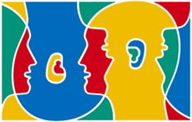
Background information on the Day
It is estimated that there are over 225 indigenous languages in Europe, without even including languages which have arrived on the continent through migration.

The specific aims of the EDL are to:
- raise awareness of the importance of language learning in order to increase plurilingualism and intercultural understanding;
- promote the rich linguistic and cultural diversity of Europe;
- encourage lifelong language learning in and out of school.
The Council of Europe and the European Commission work closely together on the coordination of the Day. The dedicated website, www.coe.int/edl, which is available in 39 languages, provides details of events taking place in celebration of the Day, as well as a wide variety of resources and activities for everyone interested in languages and language learning.

