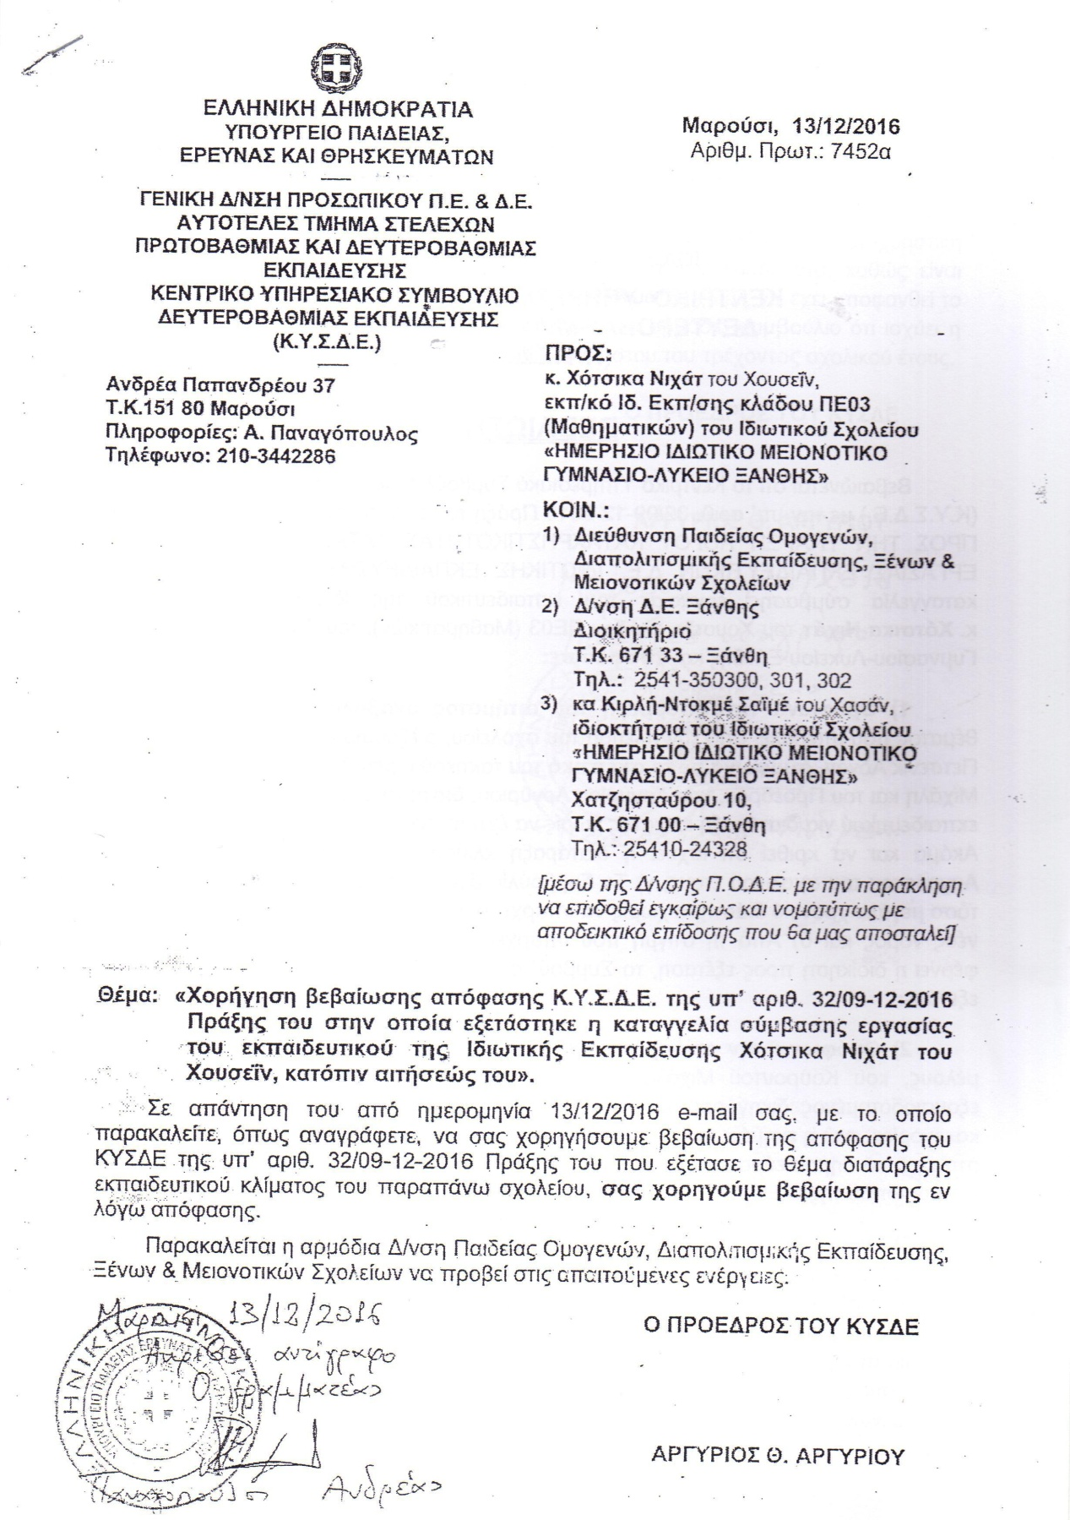

C:\Users\ANNA\Desktop\2.tif

C:\Users\ANNA\Desktop\3.tif